Eyre-site-plan
Seth Eyre
WDD 130

Overview
Purpose
This personal blog is a space to document progress, reflect on experiences, and stay accountable to personal goals. By regularly writing journal-style entries, it creates a record of challenges, lessons, and achievements over time. The blog makes it easy to look back at past entries, helping keep track of growth, patterns, and improvements. Instead of thoughts getting lost or forgotten, they become part of a timeline that shows how ideas, habits, and goals evolve, encouraging consistency, self-reflection, and continuous personal development.
Audience
Mostly for personal use although once i learn a little bit of java to make this website more functional i will make it public to those who want to tune in and see where life takes me

Branding
Website Logo
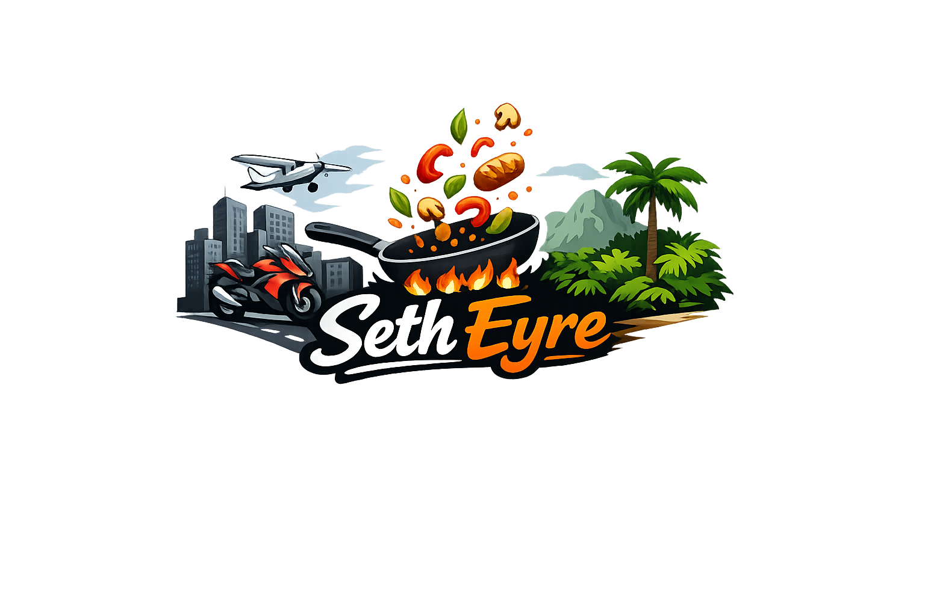

Style Guide
Color palette

Primary color | Secondary color | Primary accent | Secondary accent
F3E8C1 | 693335 | 68B0AB | 4D6F66
Typography
Heading font: Google sans
Paragraph font: open sans

Navigation
Home Daily blog catalog

Content
Anything that isn't specified in the wire frame can just be filler text for now
And images can just be stock images off of google

Wireframe
Home
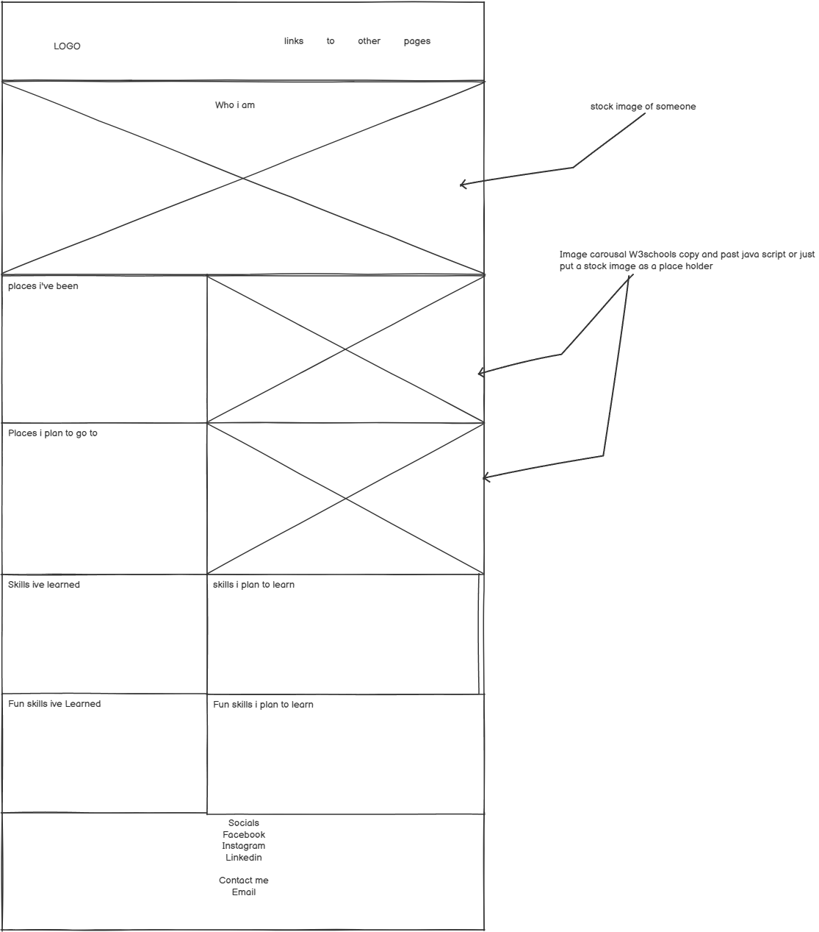

Catalog
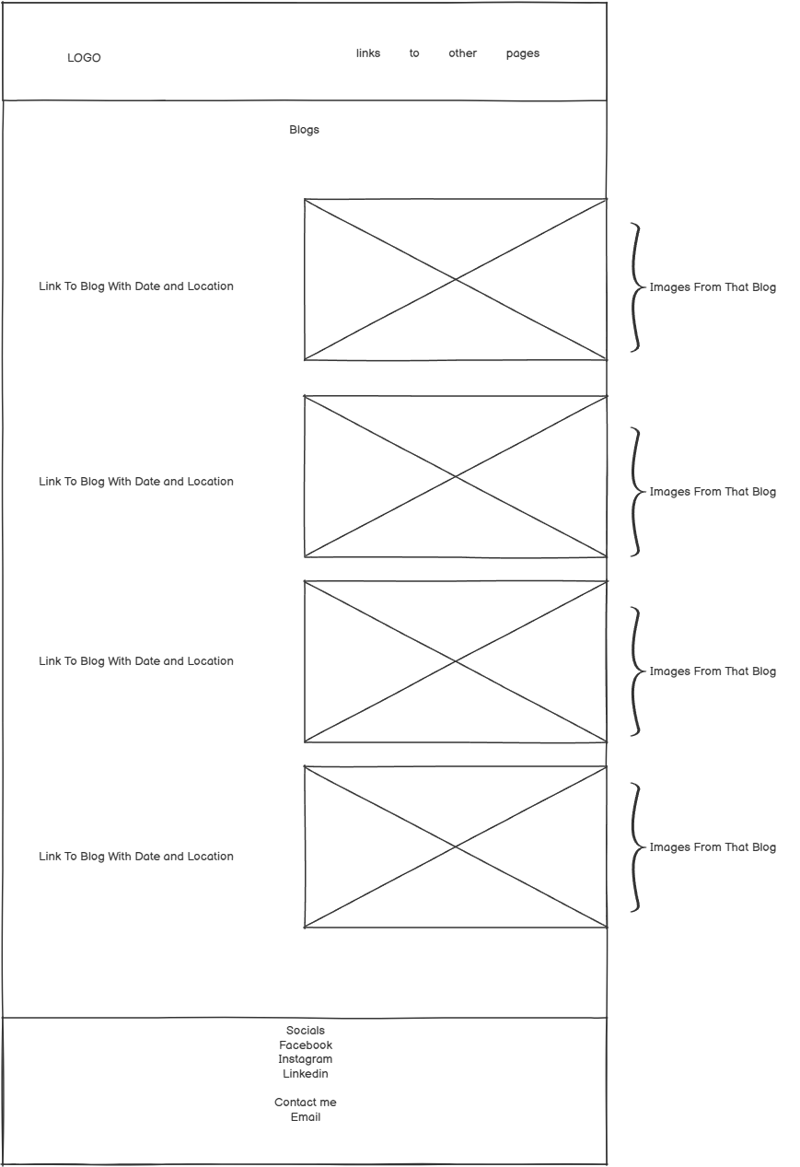

Daily blog
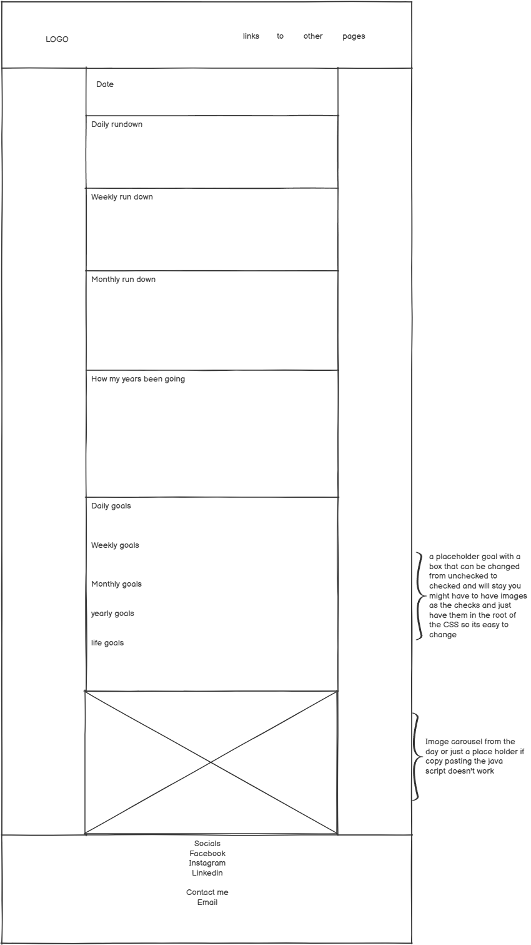
Text me at
307 677 7963
With questions

